WILLIAM D. BRYANT, PhD, CISSP, C|EH, Security+, TS/SCI clearance
bill.bryant@mtsi-va.com ♦ (334) 322-5069 ♦ LinkedIn.com/In/williambryantcyber
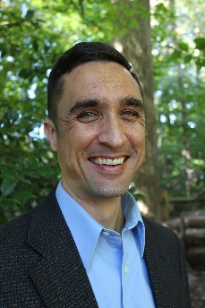
Dr. Bill “Data” Bryant is a cyberspace defense and risk leader with a diverse background in operations, planning, and strategy. He is a thought leader in the cyber defense of weapon systems and other non-traditional cyber-physical systems with multiple published works coupled with numerous operational and strategic assignments building these capabilities in complex organizations.
Bill believes that non-traditional cyber-physical systems such as aircraft and control systems are often an organization’s most critical, and least defended assets, and he is passionate about improving the defensive posture of these systems.
Bill has an unusually diverse background including more than 25 years in the Air Force where he was a fighter pilot, planner, and strategist. He helped create Task Force Cyber Secure and served as its deputy director; he also served as the Air Force deputy Chief Information Security Officer and developed and successfully implemented numerous proposals and policies to improve the cyber defense of weapon systems.
Bill currently works for Modern Technology Solutions Incorporated where he has created the Combined Secure Systems Engineering Process (CSSEP), Prioritized Integrated Cybersecurity Assessment Methodology (PICAM), and Probabilistic Mission Risk Analysis (PMRA) process. Working with the aircraft combat survivability community he developed Aircraft Cyber Combat Survivability (ACCS) to guide aircraft survivability design in this emerging area. He also supported OUSD R&E by developing a strategy and roadmap for the cyber resiliency and survivability of weapon systems across DoD, as well as developing processes for and performing cybersecurity risk assessments on various critical weapon systems.
Bill also has a wide range of academic degrees including Aeronautical Engineering, Space Systems, Military Strategy, and Organizational Management. His PhD dissertation topic was cyberspace superiority and he has multiple published works on various aspects of defending cyber-physical systems and cyberspace superiority. In addition, he holds CISSP, C|EH, and Security+ certifications.

