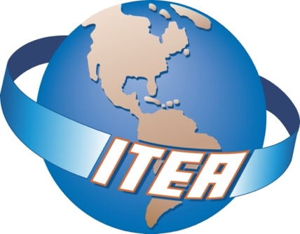

39th International T & E Symposium
Forging the 21st Century T&E Tools in an Era of Great Power Competition

September 27 – 30, 2022
Westin Town Center | Virginia Beach, VA

The Premier Global Association for Test and Evaluation Professionals

- Half-day Pre-Workshop Tutorials: Earn Continuing Professional Education Credits (CPEs)

- Keynote Speaker & Panel Discussions: Department of Defense Operational Test Agency Commanders, facilitated by DOT&E. Commanders from AFOTEC, ATEC, STARCOM, JITC, OPTEVFOR and MCOTEA.

- Technical Exchange Panels Addressing: AI and Machine Learning, Cyber, Digital Twin and Hypersonics.

- Exhibits: Increase your visibility, network with key players, and show your support and commitment to the industry and community!

- Networking: Make professional connections to grow your business network and seek out partnerships

WORKSHOP DESCRIPTION

The current Global Power Competition (GPC) climate can pose a change to the acquisition and fielding process of most systems. It is important to understand the 21st Century T&E Tools to improve testing to meet the GPC demand. How will the military budget, DoD, DHS, and Commercial Industry adjust in a time of risk and change? Is your organization ready?

This year the Symposium will be coordinated by the Hampton Roads Chapter with Volunteers from across the entire ITEA community. Please plan on both attending, and more importantly, participating in this year’s Annual Symposium. Join us and help us explore these ideas and others related to “Forging the 21st Century T&E Tools in an Era of Great Power Competition’” as part of our 39th Annual International Symposium.

Please join us in Virginia Beach, VA as members of the T&E community from academia, industry, and government come together to address the challenges associated with the great power competition. Keynote speakers, Technical Exchange panels, technical sessions, tutorials and exhibits will be part of this program. Come share your thoughts, connect with others, and learn from some of the leading experts at this Symposium.

PLANNING COMMITTEE

- Erwin Sabile, CTEP, Symposium Chair & Hampton Roads Chapter President, Booz Allen Hamilton
- Vivian Richards, Technical Chair, Splunk
- Dr. Michael Flynn, Tutorial Chair, DAU
- Stephanie Clewer, Awards Committee Chair, SA-TECH
- Dr. Michael Barton, Chief Technologist and Fellow, Parsons Corporation
- Terry Murphy, CTEP, Deputy Director, Office of Test & Evaluation, Department of Homeland Security
- Ade Britton, PhD, Lead Solution Architect, Global T&E Campaign, Qinetiq

The Symposium will contain some Controlled Unclassified Information (CUI), which will limit participation to U.S. citizens who are employees of the U.S. Federal Government or its contractors (C), or employees of the Department of Defense or its contractors (D). If you do not meet this requirement, you may be unable to attend every session. DoD common access cards (CAC) or personal identity verification (PIV) will be required for entry.

THANK YOU TO OUR SPONSORS!

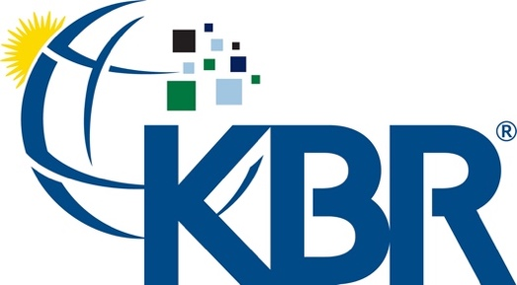

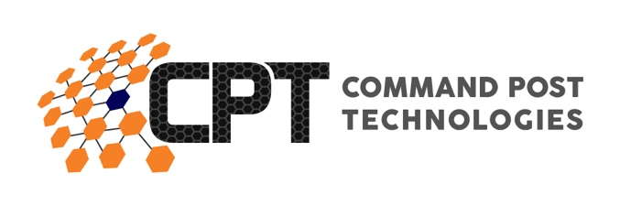

EVENTS DATE TIME

Registration Monday, September 26 3:00pm–5:00pm
Tuesday, September 27 6:30am–5:00pm
Wednesday, September 28 6:30am –5:00pm
Thursday, September 29 7:00am–5:00pm
Friday, September 30 8:00am–12:00pm

Tutorials Tuesday, September 27 8:00am–12:00pm/
1:00pm–5:00pm
(See next page for descriptions)
Exhibit Hours Wednesday, September 28 9:30am–5:00pm
Thursday, September 29 9:30am–4:30pm

Technical Sessions Thursday, September 29 2:00pm–4:00pm

Special Events
Opening Ceremony &
Keynote Speakers Wednesday, September 28 8:00am–10:00am
Plenary Sessions Wednesday, September 28 10:30am–12:00pm/
1:15pm–2:45pm
Break with Exhibitors Wednesday, September 28 10:00am–10:30am/
2:45pm–3:15pm
Technical Exchange Panels Wednesday, September 28 3:15pm–5:00pm
Evening Reception Wednesday, September 28 5:00pm–6:00pm
Plenary Sessions Thursday, September 29 7:35am–10:00am
Break with Exhibitors Thursday, September 29 10:00am–10:30am/
4:00pm–4:30pm
Plenary Sessions Thursday, September 29 10:30am–12:00pm
T&E Professional Awards Lunch Thursday, September 29 12:00pm–2:00pm
Plenary Sessions Thursday, September 29 4:30pm–5:30pm
Plenary Sessions Friday, September 30 9:00am–11:30am
DHS US Coast Guard Station Tour Friday, September 30 1:00pm

Pre-Workshop Tutorials are a separate fee from the Workshop.
Single Tutorial - $205, Two Tutorials - $385

Tuesday 27 September Tutorials

8:00 a.m. – 12:00 p.m. Morning Tutorials

DoD Test and Evaluation Across the Acquisition Lifecycle (Rapid & Mid-Tier Acquisition)
Dr. Michael Flynn CTEP, CSEP, Defense Acquisition University

An overview of the Adaptive Acquisition Frameworks guidance for Defense Acquisition System from a Test and Evaluation perspective with emphasis on the involvement in the Systems Acquisition Lifecycle and T&E's relationship to the Systems Engineering processes used throughout the lifecycle of major acquisition programs from requirements generation, through Post Milestone C. Coverage will include the latest policies and practices and the role of T&E with an overview of Agile Software practices, DevSecOps, Capabilities Based Test and Evaluation and the relationship between Developmental and Operational T&E. Focus will be on the major events that occur during each phase of acquisition, required documentation, and expected entrance and exit criteria for successfully achieving approval. The intended audiences are engineers, program managers, and industry for an understanding of DoD acquisition in relationship to T&E's involvement.

Predicting and Assessing Prototype Capability
Dr. Mark Kiemele, CTEP, Air Academy Associates

Design of Experiments (DOE) is a method that can and should be used not only in the design and development of systems, but also in the modeling and validation of prototype systems. Building useful prediction models and then validating them can ease the burden of making procurement decisions. This tutorial will examine two prototypes that are built to satisfy a common set of requirements. DOE, together with regression analysis, will be used to model the performance of each prototype. Then validation testing will be used to confirm the models and assess the performance capability of each prototype, i.e., how well the prototypes meet the requirements. This facilitates a comparison of the capabilities of the two systems, thereby enhancing the decision as to which system to pursue. There are no pre-requisites for this tutorial, as the analysis will be demonstrated via computer.

T&E as a Part of Agile Development
Dr. Robin Poston, CTEP - System Testing Excellence Program, University of Memphis, and Wayne Dumais - Deputy T&E, Department of Homeland Security (DHS)

To discuss T&E in support of agile development, we need to explore the sequence of the evolution of the agile methods, rationale for the application of different methods, compare traditional and agile software development approaches, discuss research conclusions regarding the agile method’s impact on software performance, review benefits and challenges of agile, and appreciate the fit of agile methods with Systems Acquisition Life Cycle. Furthermore, in this tutorial we will also discuss when to use agile, the role of the tester on agile projects, and various kinds of testing applicable to agile software developments.

T&E in a Digital Engineering Environment
Jean Petty, Cyber Resilience T&E Manager, Department of Homeland Security (DHS)

This tutorial will review digital engineering concepts in general and then deep dive into specifics for test and evaluation (T&E) in a digital engineering environment. The course will review concepts, methods, tools, and best practices for five Digital Engineering topic areas including models, an authoritative source of truth, technological innovation, innovative infrastructure, and workforce. Each topic area will be addressed in general, followed by discussion of specific issues and challenges for T&E. Discussion areas will include:

- How planning and the evaluation components of T&E need to evolve in the DE environment, given Model Based Systems Engineering, Mission Engineering, and automated testing.
- The characteristics of T&E tools within the DE environment and considerations and methods for automated tools selection.
- Data access, data sharing, and hurdles for building an authoritative source of truth.
- Special concerns for Cyber T&E in a Digital Engineering environment.
- Digital Engineering infrastructure and infrastructure providers.
- T&E workforce within a Digital Engineering ecosystem.
- Gaps in current infrastructure, capabilities, workforce, etc.
This course is intended for T&E professionals who are new to Digital Engineering or are beginning to implement Digital Engineering in their T&E practices. The course will include lecture, discussion, and interactive exercises.

1:00 p.m. – 5:00 p.m. Afternoon Tutorials

Incorporating T&E into Acquisition Contracts "Shift All the Way to the Left"
Terry Murphy, CTEP, Deputy Director, Office of Test & Evaluation, Department of Homeland Security (DHS)

So you’re a Test and Evaluation Manager (or Key Leader) of a program and you and your T&E working group have just finalized the programs T&E Master Plan. Looks like you’ve accomplished all the pertinent tasks for T&E and ready for execution. Right? Not so fast, have you ever heard the term if it’s not written into the contract it probably won’t happen? To many of our T&E professionals are steeped in technical expertise and key on development of sound well defined T&E plans, but all too often they lack program management broness to understand they’ve missed critical steps. That being said, has the T&E manager coordinated with their programs contracting officer, contract specialist and or contracting officer’s representative? Probably not.

This tutorial will provide the T&E professional an overview and process for inclusion of T&E equites into the acquisition contracting artifacts. The goal of this tutorial is not to make T&E professionals contract experts, but rather provide them a keen understanding of their “Key” role, responsibilities, processes, and as key players within this process ensure T&E equities are included within acquisition contracts.

The main focus will leverage the initial procurement notice released to industry per Federal Acquisition Regulation (FAR) Part 15, the Request for Proposal (RFP). Topics will include:
- Request for Proposal background and content
- Detailed overview of each RFP Part and Section with discussion on inclusion of T&E equites based on lessons with examples
- Discussion on the Statement of Work (SOW) and or Statement of Objectives (SOO) - Differences, purposes, and how the T&E professionals assist in the development

It is critical that our T&E professionals have a full understanding of their “Key” role within the program contract development process. Without the T&E professional working side-by-side the contracting Team there are NO guarantees that T&E equities will be clearly articulated and communicated within the contracting documents. The T&E professional is the key to ensuring that T&E is accurately, effectively, and with clarity included within the program contract actions, thereby reducing:

- Confusion
- Miss-interruptions
- Unclear requirements

There is a gap for our T&E professionals within this area of knowledge, and it’s for that reason, this tutorial is recommended.

Security, Orchestration, Automation and Response (SOAR) - Big Data Analytic, Cyber Playbooks, Human Interface
Vivian Richards, Splunk

Alert Fatigue, juggling too many security tools, limited talent pool. These are three critical problems that can burden even the most committed security operations team. What if there was a way to automate detection, investigation, and response? Using a Security Orchestration, Automation and Response tool like Splunk SOAR can help you respond to security threats faster and decrease your average time to detect, investigate, and remediate malware.

By automating repetitive security tasks, like alert triage, Splunk SOAR can help you work smarter and focus on mission-critical tasks. Splunk SOAR technology integrates with your existing security tools to make them work better together and can help you get the most out of your current security investments and strengthen your overall security posture.

Automating a majority of that security workload with automated playbooks means your team doesn’t have to do it manually. This frees up time for your team to focus on other mission critical tasks. In short, your team can do more with the people you already have.

In this session, we will discuss how automation can help a security team establish better standard operating procedures to help the team be more effective using built-in case management to apply more operational rigor around security processes.

Think Like an Adversary
Elly Millar, Defense Acquisition University, Cybersecurity Professor

Cyber threat landscape is constantly evolving. Organizations continue to expand their digital edge, heavily relying on mobile and Internet-of-Things (IoT) devices. COVID-19 also accelerated digital transformation and cloud adoption as millions of employees were forced to work from home. People working remotely has opened up new avenues for cyber threat actors to target both individuals and organizations all the while making it more challenging for local Information Technology (IT) staff to have visibility and control over the organization’s assets. Increase in collaboration across industries and academia also contribute to the attack surface growth due to the unknown nested third party relationships. Cybersecurity issues are a day-to-day challenge for healthcare, financial, manufacturing, government and other sectors. Every communication path represents a risk and traditional method to secure the IT infrastructures do not work effectively on new modern attack surfaces. Additionally, decreasing costs of computation and data storage make it extremely easy for the cyber threat actors to adapt quickly and become more innovative in their attacks. Cybersecurity challenges are daunting, but instead of throwing in the towel, start to think like an adversary to implement proactive and effective cybersecurity measures. This tutorial will lead the audience with limited background in cybersecurity to understand the concept of cyber threat intelligence starting with the cybersecurity trends, cyber threat terminologies and concepts including attack surface characterization. Additionally, the tutorial will introduce the audience to the Department of Defense Cyber Table Top (CTT) methodology including a CTT Lite exercise to better understand the adversarial perspectives. Knowledge gained from the tutorial will help build a foundation for those with limited to no cybersecurity experiences, but also beneficial to any cybersecurity professionals looking to apply threat engineering and/or threat based cyber testing with an ultimate goal of achieving organizational (or program’s) operational resiliency.

TRMC Solutions for Overcoming Challenges in Distributed T&E
Gene Hudgins, JMETC/TENA Team, Test Resource Management Center

The Test and Training Enabling Architecture (TENA) was developed as a DoD CTEIP project to enable interoperability among ranges, facilities, and simulations in a timely and cost-efficient manner, as well as to foster reuse of range assets and future software systems. TENA provides for real-time software system interoperability, as well as interfaces to existing range assets, C4ISR systems, and simulations. TENA, selected for use in JMETC events, is well-designed for its role in prototyping demonstrations and distributed testing.

Established in 2006 under the TRMC, JMETC provides readily-available connectivity to the Services’ distributed test capabilities and simulations. JMETC also provides connectivity for testing resources in the Defense industry and incorporation of distributed testing and leveraging of JMETC-provided capabilities by programs and users has repeatedly proven to reduce risk, cost, and schedule. JMETC is a distributed LVC testing capability developed to support the acquisition community during program development, developmental testing, operational testing, and interoperability certification, and to demonstrate Net-Ready Key Performance Parameters (KPP) requirements in a customer-specific Joint Mission Environment.

JMETC is the T&E enterprise network solution for secret testing, and uses a hybrid network architecture – the JMETC Secret Network (JSN), based on the SDREN. The JMETC MILS Network (JMN) is the T&E enterprise network solution for all classifications and cyber testing. JMETC provides readily available connectivity to the Services' distributed test capabilities and simulations, as well as industry test resources. JMETC is also aligned with JNTC integration solutions to foster test, training, and experimental collaboration.

TRMC Enterprise Big Data Analytics (BDA) and Knowledge Management (BDKM) has the capacity to improve acquisition efficiency, keep up with the rapid pace of acquisition technological advancement, ensure that effective weapon systems are delivered to warfighters at the speed of relevance, and enable T&E analysts across the acquisition lifecycle to make better and faster decisions using data that was previously inaccessible, or unusable. BDA is the application of advanced tools and techniques to help quickly process, visualize, understand, and report on data. JMETC has demonstrated that applying enterprise-distributed BDA tools and techniques to T&E leads to faster and more informed decision-making that reduces overall program cost and risk.

This tutorial will inform the audience as to the current impact of TENA, JMETC, and BDA on the T&E community; as well as their expected future benefits to the range community and the warfighter.

Wednesday 28 September Plenary Sessions, Technical Exchange Panels, & Exhibits

8:00 a.m. Opening Ceremony:
Presentation of Colors
National Anthem
Mr. Bruce Einfalt – ITEA President

8:15 a.m. Welcome:
Mr. Erwin Sabile, CTEP, Booz Allen Hamilton - Symposium Chair & Hampton Roads Chapter President

8:30 a.m. Keynote Speaker: Congresswoman Elaine Luria, Vice Chair for House Armed Services Committee

9:15 a.m. Honorable Nickolas H. Guertin, Director, Operational Test & Evaluation (DOT&E)

10:00 a.m. 30-MINUTE BREAK WITH THE EXHIBITORS

10:30 a.m. DoD Operational Test Agency Commanders panel facilitated by Dr. Raymond O'Toole, Principal Deputy Director, Operational Test and Evaluation, OSD

Panelists:
- Brig Gen Rawls, Commander, Air Force Operational Test and Evaluation Center
- Major General James Gallivan, Commanding General, Army Test and Evaluation Command
- Brig Gen Shawn Bratton, Commander, Space Training and Readiness Command
- Captain Robert Matthias, USN, Commander, Joint Interoperability Test Command
- Robin Locksley, (SES) Director, Operational Test and Evaluation Force
- Col Donald McDaniel, Director, Marine Corps Operational Test and Evaluation Activity

12:30 p.m. Lunch

1:15 p.m. Prototype & Rapid Fielding Panel facilitated by George Rumford, (SES) Director (acting) and Principal Deputy, Test Resource Management (TRMC)

Panelists:
- TBD
- TBD
- TBD

2:45 p.m. 30-MINUTE BREAK WITH THE EXHIBITORS

3:15 p.m. Technical Exchange Panels will run concurrently from 3:15pm to 5:00pm.

AI and Machine Learning: How to Test the Trust Worthiness & Human System Integration?
Facilitator: Daniel Porter, IDA

Panelists (invited):
- Dr. Sandra Hobson, Deputy Director for Strategic Initiatives, Policy and Emerging Technologies, Office of the Director, Operational Test and Evaluation, Office of the Secretary of Defense
- Dr. Laura Freeman, Director, Intelligent System Lab, Virginia Tech Hume Center Associate and Professor of Research, Department of Statistics Assistant Dean for Research, College of Science
- Dr. Jane Pinelis, Chief, Test and Evaluation, DoD Joint Artificial Intelligence Center
- Rory Quinn, Branch Head, Adaptive Threat Force Branch, Marine Corps Warfighting Laboratory, Lieutenant Colonel, U.S. Marine Corps (retired)
Cyber War
Facilitator: Alex Hoover, Deputy Director for Cybersecurity Office of Systems Engineering Capability Development Support, Department of Homeland Security

Panelists:
- Dr. Robin Poston, CTEP, Vice Provost and Dean of the Graduate School, Professor of Business Information and Technology, and Director of the Systems Testing Excellence Program, FedEx Institute of Technology, The University of Memphis
- Dr. Garfield Jones, Associate Chief of Strategic Technology, U.S. Department of Homeland Security (invited)
Digital Twin in Test & Evaluation
Facilitator: Jeremy Werner, PhD, Science Advisor, DOT&E

Panelists:
- Sankaran Mahadevan, PhD, Vanderbilt University (National Security Innovation (NSIN) Partner) (invited)
- William Nichols, Principal Director, Booz Allen Hamilton (invited)
- Ade Britton, PhD, Lead Solution Architect, Global T&E Campaign, Qinetiq
- Jim Leathrum, PhD, Associate Professor and Chief Departmental Advisor in the Department of Modeling, Simulation and Visualization Engineering at Old Dominion University (invited)

Accelerating T&E for Hypersonics *CUI*
Facilitator: Chris Short, Booz Allen Hamilton

Panelists:
- Brooke Pyne, Director, S2MARTS, NSTXL
- Daniel Millman, PhD, Chief Technology Officer, Stratolaunch
- Martin Swany, Indiana University/IN3 (NSIN Venture Community) (invited)
- Geoff Wilson, T&E/S&T PM, Test Resource Management Center (invited)
- Daniel Ogg, USAF

5:00 p.m. EVENING RECEPTION

Thursday 29 September

Plenary Sessions, Technical Sessions, T&E Awards Luncheon & Exhibits

7:30 a.m. Welcome and overview of the day’s events by Mr. Erwin Sabile, CTEP, Symposium Chair

7:45 a.m. Featured Speaker: James Wells (SES), CTEP, Director Office of Test and Evaluation, Department of Homeland Security

8:30 a.m. Critical and Emerging Technologies Panel facilitated by George Rumford, representing Office of the Under Secretary of Defense for Research and Engineering
Panelists:
- TBD
- TBD
- TBD

10:00 a.m. 30-MINUTE BREAK WITH THE EXHIBITORS

10:30 a.m. T&E Workforce along with T&E Tools in support of T&E Professionals Panel facilitated by Terry Murphy, CTEP, Deputy Director, Office of Test & Evaluation, Department of Homeland Security (DHS)

Panelists:
- Dr. Robin Poston, CTEP, Director of the System Testing Excellence Program, FedEx Institute of Technology, The University of Memphis
- Dr. Laura Freeman, Director, Intelligent System Lab, Virginia Tech Hume Center Associate and Professor of Research, Department of Statistics Assistant Dean for Research, College of Science
- Kenneth Stefanek, Learning Director for Test and Evaluation, Defense Acquisition University (DAU)
- Dr. Darryl Ahner, CTEP, Director, Scientific Test and Analysis Techniques Center of Excellence (STAT COE)
- Anne Sparrenberger, Chief of Staff at FedEx Services

12:00 p.m. ITEA T&E Professional Awards Luncheon – Join us at this special awards luncheon honoring our recipients who have made significant contributions to advancing the Test and Evaluation (T&E) profession.

2:00 p.m. Technical Track Sessions

Chair | Time | Title | Presenter(s)
Session 1: Cyberspace Test Technology
Min Kim, Deputy Executing Agent for the TRMC T&E/S&T Cyberspace Test Technology (CTT) | 2:00 | Activity and Content Enhancement – Next Gen Traffic Generation Toolkit | Steve Durst, Terry Champion, Eric Renouf, Skaion
 | 2:30 | Measure and Share: TRMC T&E/S&T Cyberspace Test Technology’s project to improve Cyber T&E impacts across DoD | Dr. Mike Shields, TRMC T&E/S&T and Pete Firey, MITRE
 | 3:00 | Advanced Automated Machine Learning System | Dr. Himanshu Upadhyay, Dr. Leonel Lagos, Santosh Joshi, Jayesh Soni, and Michael Perez, Florida International University
 | 3:30 | DoD Fuzzing Framework | Arch Owen, Draper – National Security and Space
Session 2: Young T&E Professionals
Wayne Dumais, Deputy T&E, Department of Homeland Security (DHS) | 2:00 | Tara Francis | T&E: it's all about solution assurance, right?
 | 2:30 | John Spahlinger | Operational Testing; how MCOTEA and Marines support the acquisition process
 | 3:00 | Kalvin Krompetz | TBD
 | 3:30 | Wayne Dumais - Deputy T&E, Department of Homeland Security | Traditional Young Guns
Session 3: How Do Know My M&S is Good Enough?
Ade Britton, PhD, Lead Solution Architect, Global T&E Campaign, Qinetiq | 2:00 | TBD | TBD
 | 2:30 | TBD | TBD
 | 3:00 | TBD | TBD
 | 3:30 | TBD | TBD
Session 4: Agile
 | 2:00 | Actuating Thru Agile – An Incremental Test Approach | Joshua Strain, Raytheon
 | 2:30 | Test Resource Management Center - Autonomy and AI Test Technologies | Catherine Tadlock, TRMC T&E/S&T AAIT Chief Engineer
 | 3:00 | TBD | TBD
 | 3:30 | TBD | TBD

4:00 p.m. 30-MINUTE BREAK WITH THE EXHIBITORS

4:30 p.m. T&E in the age of Digital Twins and In-Space Manufacturing Panel facilitated by COL Sacha N. Tomlinson, United States Space Force, STARCOM Test Enterprise Division Chief

Panelists:
- James Reilly, PhD, Booz Allen Hamilton, Senior Executive Advisor for the Global Defense Group (former NASA Astronaut)
- Swami Iyer, President of Aerospace Systems, Virgin Galactic (invited)
- Brad Appel, Chief Engineer, Ursa Major (invited)

Friday 30 September Plenary Session, Closeout Speaker & Tour

9:00 a.m. Welcome and overview of the day’s events by Mr. Erwin Sabile, CTEP, Symposium Chair

9:10 a.m. State of ITEA presented by ELK Management

9:25 a.m. DOD Initiatives for Trusted Autonomy on the Future Battlefield panel facilitated by Dr. Jaret C. Riddick, Principal Director for Autonomy, Office of the Undersecretary of Defense for Research and Engineering for Modernization

Panelists:
- Mike Di Paolo, SETA, PD Autonomy
- TBD
- TBD

10:55 a.m. Closeout Speaker: Dr. Raymond O'Toole, Principal Deputy Director, Operational Test and Evaluation, OSD

11:30 a.m. Workshop Concludes

1:00 p.m. DHS US Coast Guard Station and Cutters Tour

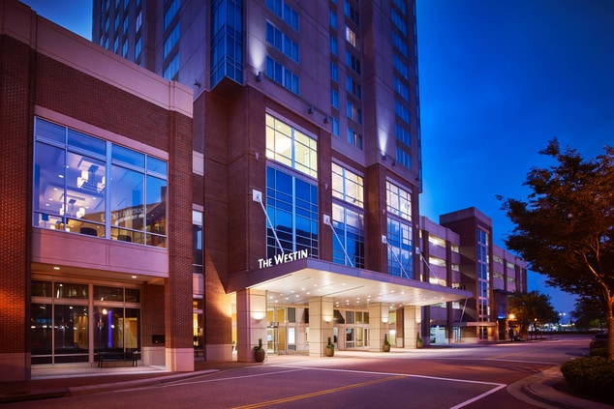
Westin Virginia Beach Town Center

Event Location
All events including tutorials, technical sessions, and exhibits, will occur on the hotel property. All events, including the opening ceremony and reception, will be clearly marked with signs. The Westin is located at 4535 Commerce St., Virginia Beach, VA 23462. Tel. 757-557-0550

Hotel Reservations
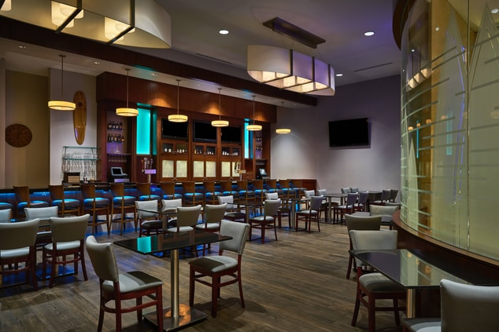
ITEA is pleased to offer a special government per diem rate of $106 per night. Please specify that you will be attending the ITEA workshop when booking your reservation.

Room Block Cut-Off: August 26, 2022

Reservations via Web: Westin Reservation Link

Cancellations: The hotel requires a 48-hour cancellation
notice prior to the reservation date. Late cancellations will
result in the first night’s stay being billed to your credit
card.

Check-In/Check-Out: Check-In time is 4:00pm and Check-out time is 12:00pm.

Internet: Free WiFi throughout the hotel (includes convention space and sleeping rooms).

Parking: Free

Extras: The hotel is located in the heart of Virginia Beach Town Center. The hotel is withing walking distance to over 25 restaurants, shopping, learning institutions and 6 entertainment venues which include APEX Entertainment, 2 performing arts centers, a comedy club, paint bar, and movie theater.

Registration Information
Regular Registration includes two lunches, breaks, & Networking Reception.

**Join as a member and receive $150 discount on your registration. Only $45 for govt/military and $95 for industry.

NOTE: Pre-Symposium Tutorials require a separate fee from the Workshop.

Early Registration prior to August 19
$645 - Regular Registration
$495 - ITEA Member / Government Employee / Active Duty Military
Regular Registration August 20-September 9
$745 - Regular Registration
$595 - ITEA Member / Government Employee / Active Duty Military
Late Registration after September 9
$845 - Regular Registration
$695 - ITEA Member / Government Employee / Active Duty Military
Early T&E Career Professional (less than 5 years of T&E experience) VERIFICATION REQUIRED – Includes two Lunches, two breaks, and the Networking Reception.
$ 95 – Early registration prior to August 19th
$195 – Registration August 20th – September 9th
$295 – Late Registration after September 9th
Download verification form here
Pre-Workshop Tutorials (requires a separate fee from the Workshop)
Single Tutorial - $205, Two Tutorials - $385
Special Registrations
- $150 - Plenary Speaker, Panel Chair, Session Chair, Tutorial Secondary Instructor
- $395 - Panelist, Technical Session Presenter
- $150 - EXHIBIT HALL ONLY (Includes meals and Networking Reception/No access to Plenary or technical sessions)
- $50 - FULL-TIME STUDENT (ID Required)
- $400 One day only

SUBSTITUTION AND CANCELLATION POLICY: Substitutions are permitted. Refunds are not available within ten (10) days prior to the start of the event. Requests for cancellation submitted between ten (10) to 45 days prior to start date of the event will be subject to a $250 cancellation fee. Requests for cancellation greater than 45 days prior to the start date of the event will be subject to a $100 cancellation fee.

