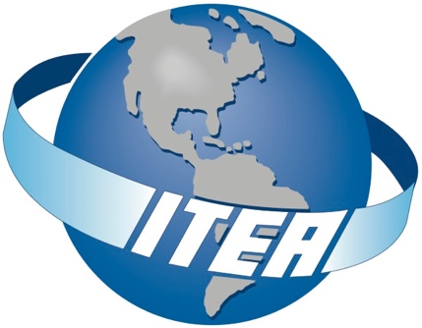

Range of the Future

May 16 – 19, 2022
Tuscany Suites & Conference Center | Las Vegas, NV

The Premier Global Association for Test and Evaluation Professionals

- Full-day and Half-day Pre-Workshop Tutorials: Earn Continuing Professional Education Credits (CPEs)

- Keynote Speaker & Panel Discussions: Select Senior Military, Civilian and Private Industry Leaders will present current and developing concepts in instrumentation and future needs to prepare the T/E community to meet the challenges of the Future Range. A Hands On Lab concept will be showcased to bring instrumentation concepts close and personal.

- Technical Sessions: Sessions addressing Cyber, Digital Engineering, Cellular Telemetry, Phased Array Antennas and more!

- Exhibits: Increase your visibility, network with key players, and show your support and commitment to the industry and community!

- Networking: Make professional connections to grow your business network and seek out partnerships

WORKSHOP DESCRIPTION

At a future test day involving several Major Range and Test Facility Bases(MRTFBs) , at O Dark Thirty, the sleek, autonomous, hypersonic air defense missile burst from its launcher and streaked into the Dark Sky. Within seconds, the weapon acquired the swarm of targets from off-board sensors in the Air, Land, Sea and Space; all communicating through the satellite and terrestrial networks in a multi-domain engagement. The network provides information to other weapon systems at the ready to engage as continuous information from the range instrumentation sensors, depict the success or lack of success of the engagement. This system of system motif assures superior and decisive action against any adversary. Suddenly, the swarming targets make a violent but preprogrammed maneuver to counter the myriad of weapon systems engaging, prompting an associated action in all the system of systems engaging. Range Control Systems automatically merged all range sensor data for the best estimate of trajectory of all players with data coming from Radar, GPS, Optics, Telemetry, and other systems operating in a remote sensing configuration driven by AI, Machine Language, and special data fusion algorithms. The resultant data was critical for the test range customers’ decision-making processes and validation of their models and simulations as well “for record” evaluations of the individual weapons systems and an integrated multi-Domain holistic evaluation. At the involved MRTFBs, this complex orchestration of threats, advanced interceptors, and equally advance data collection instrumentation, is just another day at the worlds most sophisticated open-air test capability.

Yes, the above is a vision of the future and not yet being done today; but the reality is it is closer than you think and for us to support emerging weapon systems today, we have to accelerate our instrumentation system developments to keep pace and assure readiness in these emerging challenging environments. Understanding emerging technologies is critical to prepare the Range of the Future.

Our theme this year is Range of the Future recognizes the importance of the Services working together in preparing to meet the challenges of the scenario I painted to you above. This Workshop will support our need to be alert and aware of all technological developments that may have an impact on our test and evaluation operations. This workshop will discuss selected tenets of the various sensor instrumentation support to include the network, communications, and the massive resultant data. Plenary Discussions, tutorials and technical sessions will lead to a thorough and relevant discourse at this workshop and aid those in attendance, to prepare for the future.

Please join us at the 2022 ITEA Test Instrumentation Workshop to share your experiences, lessons learned, and solutions to the problems we face in today’s constrained test and evaluation environments.

PLANNING COMMITTEE

- Wendy Peterson, Program Chair, Edwards AFB
- Charles Garcia, Workshop Advisor, ITEA Ambassador
- Garo Panossian, Technical Chair, Edwards AFB
- Harry Cooper, Co-Technical Chair, JT4
- Jim Alich, Tutorial Chair, 412 TW

THANK YOU TO OUR SPONSORS!

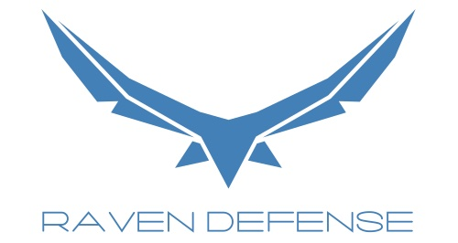
Platinum & Networking Reception

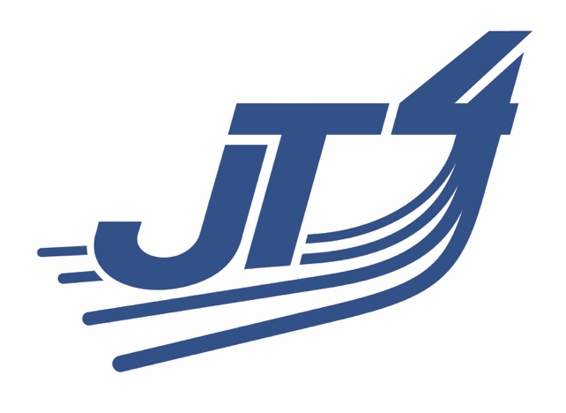
Platinum

Gold

EVENTS DATE TIME

Registration Monday, May 16 10:00am–5:00pm
Tuesday, May 17 7:00am–5:00pm
Wednesday, May 18 7:00am –5:00pm
Thursday, May 19 7:00am–5:00pm

Tutorials Monday, May 16 1:00pm–5:00pm Tuesday, May 17 8:00am–12:00pm and
8:00am–5:00pm

(See next page for descriptions)
Exhibit Hours Wednesday, May 18 9:00am–5:00pm
Thursday, May 19 9:00am–4:00pm

Technical Sessions Wednesday, May 18 10:30am–12:30pm/
1:30pm–3:30pm
Thursday, May 19 10:30am–12:30pm/
1:30pm–3:30pm

Special Events
Opening Ceremony &
Keynote Speaker Wednesday, May 18 8:00am–10:00am
Reception in the Exhibit Halls Wednesday, May 18 5:00pm–7:00pm

NEW!

Hands on Lab Experience
The Hands on Experience is a one of a kind interactive learning lab designed to promote education and engagement between attendees and vendors. Attendees will visit each station actively engaging, learning and participating in various hands-on activities.

Labs will start on Tuesday at 1:30pm and run till 12:00pm on Thursday. See schedule below for exact time. Contact sean.conway.1@us.af.mil for more information or to schedule your company.

Pre-Workshop Tutorials are a separate fee from the Workshop.
Single Tutorial - $205, Two Tutorials - $385

16-May Tutorials

1:00 p.m. – 5:00 p.m. Afternoon Tutorials

Fundamentals of Telemetry Ground Stations
Mark McWhorter, V.P. of Sales & Marketing, Lumistar Inc.

This course is designed to present to the student the fundamental design features of a typical range telemetry ground system. Topics to be discussed will be the major sub-systems and components used, such as track antenna, multicoupler, receiver/combiner, demodulation, bit synchronization, data recording and playback, time, decommutation and simulation, and real time displays of telemetered parameters. The student will be exposed to a few mathematical exercises, such as “link analysis” calculations to help determine the “sensitivity” of the ground station and resultant system tradeoffs. After having completed the course, the student will have a better understanding of concepts related to RF and data processing of flight telemetry.

IRIG 106-17 Chapter 7 Packet Telemetry Downlink Basis and Implementation Fundamentals
Johnny Pappas, Safran Data Systems, Inc.

This course will focus on presenting information to establish a basic understanding of the 2017 release of the IRIG 106, Chapter 7, Packet Telemetry Downlink Standard. It will also focus on the implementation of airborne and ground system hardware and methods to handle IRIG 106, Chapter 7, Packet Telemetry data. The presentation will address the implementation of special features necessary to support legacy RF Transmission, data recording, RF Receiving, Ground Reproduction, and Chapter 10 data processing methods.

Telemetry over IP
Gary Thom, Delta Information Systems

As telemetry ranges are making the move to network centric architectures, it is worth considering the lessons learned over the previous 10 years of designing, installing, troubleshooting and optimizing telemetry data distribution over IP networks. This tutorial will begin with the motivation for moving to Telemetry over IP (TMoIP). It will then provide a basic networking foundation for understanding TMoIP and TMoIP formats. With this basis, we will be able to discuss network design considerations and tradeoffs for a successful TMoIP deployment. Finally, we will present some of the real-world problems and issues that may arise in a TMoIP system and the troubleshooting techniques that can be used to resolve them.
Test and Training Solutions with TENA, JMETC, and BDKM
Gene Hudgins, JMETC/TENA

The Test and Training Enabling Architecture (TENA) was developed as a DoD Central Test and Evaluation Investment Program (CTEIP) project to enable interoperability among ranges, facilities, and simulations in a timely and cost-efficient manner, as well as to foster reuse of range assets and future software systems. TENA provides for real-time software system interoperability, as well as interfaces to existing range assets, C4ISR systems, and simulations. TENA, selected for use in Joint Mission Environment Test Capability (JMETC) events, is well-designed for its role in prototyping demonstrations and distributed testing.

JMETC is a distributed LVC testing capability developed to support the acquisition community during program development, developmental testing, operational testing, and interoperability certification, and to demonstrate Net-Ready Key Performance Parameters (KPP) requirements in a customer-specific Joint Mission Environment.

JMETC uses a hybrid network architecture. The JMETC Secret Network (JSN), based on the SDREN, is the T&E enterprise network solution for secret testing. The JMETC Multiple Independent Levels of Security (MILS) Network (JMN) is the T&E enterprise network solution for all classifications and cyber testing. JMETC provides readily available connectivity to the Services' distributed test capabilities and simulations, as well as industry test resources. JMETC is also aligned with the Joint National Training Capability (JNTC) integration solutions to foster test, training, and experimental collaboration.

TENA provides the architecture and software implementation and capabilities necessary to quickly and economically enable interoperability among range systems, facilities, and simulations. TENA also fosters range asset reuse for enhanced utilization and provides composability for assembling rapidly, initialize, test, and execute a system from reusable, interoperable elements. Because of its field-proven history and acceptance by the range community, TENA provides a technology already deployed and well tested within the DoD.

Enterprise Big Data Analytics (BDA) and Knowledge Management (BDKM) has the capacity to improve acquisition efficiency, keep up with the rapid pace of acquisition technological advancement, ensure that effective weapon systems are delivered to warfighters at the speed of relevance, and enable T&E analysts across the acquisition lifecycle to make better and faster decisions using data that was previously inaccessible, or unusable. BDA is the application of advanced tools and techniques to help quickly process, visualize, understand, and report on data. JMETC has demonstrated that applying enterprise distributed BDA tools and techniques to T&E, leads to faster and more informed decision making that reduces overall program cost and risk.

This tutorial will inform the audience as to the current impact of TENA, JMETC, and BDA on the T&E community; as well as their expected future benefits to the range community and the warfighter.

5G NR Specification and System Engineering Aspects
Achilles Kogiantis, PhD, and Kiran Rege, PhD, Peraton Labs

5G wireless cellular networks, based on the 3GPP standard, are being widely deployed in the United States and the rest of the world. 5G is expected to increasingly dominate the worldwide cellular communication market due to its flexibility, wide adoption, and an ever-expanding supplier global ecosystem. The flexible 5G architecture allows multiple networks widely differing in physical, reliability and power characteristics to be supported over a common infrastructure. This flexibility will be particularly useful to Testing Ranges where subnetworks simultaneously supporting high-bandwidth terrestrial communications, low-power sensors and broadband airborne telemetry systems can be flexibly implemented over a common 5G platform. This tutorial is intended to familiarize the Testing Range professionals with a) the key features of the 5G standards specifications – the basic vision, network architecture, the physical and MAC-layer characteristics of the air-interface, and b) the 5G system engineering aspects of deploying a new private network, dimensioning and planning, and its performance assessment. The first half of the tutorial will discuss the 5G standards specifications, while the second half will cover the 5G systems engineering aspects.

17-May Tutorials

8:00 a.m. – 5:00 p.m. Full Day Tutorials

Basics of Aircraft Instrumentation Systems
Bruce Johnson, NAWCAD

This course will cover a wide variety of topics related to Aircraft Instrumentation. Data, Telemetry, Instrumentation System Block Diagram, Standards, Data Requirements, Transducers / Specifications, Video, 1553 Bus, Using Requirements to Configure an Analog Data Channel, Creating a PCM Map to Obtain a Sample Rate, Telemetry Bandwidth, Record Time, GPS, Audio, Telemetry Attributes Transfer Standard (TMATS), and Measurement Uncertainty - Interpreting the Results. This is great introduction for new hires or a refresher for current employees.

Test Foundations for Flight Test
Jessica Peterson, Technical Director 412th Operations Group/ Assistant Professor USAF TPS

The Test Foundations curriculum is designed to equip students with an introduction to the knowledge and skills necessary to be successful flight testers. The curriculum introduces the basic “vocabulary” of the various phases of a flight test program, from program initiation through final reporting. The curriculum begins with a basic Systems Engineering problem decomposition approach applied to various flight test programs. Next the various stages of the lifecycle of a normal test program are decomposed into the subparts of Planning, Execution, Analysis, and Reporting (PEAR). Planning: the basic development strategy for test planning with specific and achievable objectives and the concepts of hazard and risk identification in safety planning will be introduced. Execution: the fundamentals of flight test control and conduct will be presented with an emphasis on the elements required for safe and efficient test control and conduct. Consideration for test execution will include required personnel, mission preparation, test card generation, communications plans, execution techniques, and post-test debrief. Finally, basic analysis methods and approaches to presenting technical results will be presented. The course will culminate with an in-class exercise to apply the Test Foundations content to test vignettes based on real-world scenarios.

8:00 a.m. – 12:00 p.m. Morning Tutorials

Basic Overview of Telemetry
Gary Thom, Delta Information Systems, Inc.

This course provides a very high level introduction of basic telemetry concepts and components. The course begins with onboard vehicle under test discussing sensors, signal conditioning, commutation, modulation and transmission. It continues on the ground with receivers, data distribution, decommutation, processing and display. The course includes additional concepts like IRIG 106 Chapter 10 and 11 recording and distribution formats as well as IRIG 106 Chapter 7 packet data over PCM.

Troubleshooting Ethernet Data with Wireshark
Paul Ferrill, ATAC

The “Troubleshooting Ethernet Data with Wireshark” tutorial will use real-world aircraft data to demonstrate how to use the open source program Wireshark to both view data and troubleshoot problems. The class will include presentation and hands-on usage of Wireshark to look at data as if you were connected to the Ethernet network on an airplane and if you were connected to an IRIG 106 Chapter 10 recorder broadcasting data over UDP. We’ll start out with a brief overview of Ethernet fundamentals and then get right on to using Wireshark.

18-May Plenary Sessions, Technical Sessions, & Exhibits

8:00 a.m. Opening Ceremony:
Presentation of Colors
National Anthem
Mr. Bruce Einfalt – ITEA President

8:15 a.m. Welcome:
Ms. Wendy Peterson, TIW Program Chair & Antelope Valley Chapter President

8:30 a.m. Welcome by Brigadier General Matthew Higer, Commander, 412th Test Wing,
Edwards AFB

8:40 a.m. Keynote Speaker: Major General Evan C. Dertien, Commander, Air Force Test Center, Edwards Air Force Base

9:20 a.m. Featured Speaker: Chris Wilcox, (SES), Deputy Director, Air Force T&E

10:00 a.m. 30-MINUTE BREAK IN THE EXHIBIT HALL

10:30 a.m. Technical Track Sessions
- Cellular Telemetry
- Opening the Door to Digital Engineering
- Cybersecurity
- AFWERX
12:30 p.m. Lunch in the Exhibit Hall

1:30 p.m. Hands on Lab

1:30 p.m. Technical Track Sessions
- Telemetry Networks Deployment
- Range Instrumentation
- TM Phased Array Antennas: Interfaces, Architectures, and Test Results
- Intellectual Property
3:30 p.m. 30-MINUTE BREAK IN THE EXHIBIT HALL

4:00 p.m. Featured Speaker: Hans Miller, Project Leader, OSD Programs, The MITRE Corporation

5:00 p.m. RECEPTION IN THE EXHIBIT HALL

19-May Plenary Sessions, Technical Sessions, & Exhibits

8:00 a.m. Welcome and overview of the day’s events by Ms. Wendy Peterson – TIW Program Chair
8:10 a.m. Featured Speaker: Sean McMorrow, (SES), Associate Center Director for Mission Support, NASA Armstrong Flight Research Center

8:50 a.m. Featured Speaker: Tom Dowd, Director, Ranges / Targets Operations, Instrumentation & Labs, Naval Air Warfare Center Weapons Division, Naval Air Systems Command

9:30 a.m. 30-MINUTE BREAK IN THE EXHIBIT HALL

10:00 a.m. Technical Track Sessions
- WSMR Instrumentation Suite
- Mission Control Room / Distributed Test Operations
- Phased Array TM Developments Intellectual Property
- TBD
12:00 p.m. Lunch in the Exhibit Hall

1:00 p.m. Hands on Lab

1:00 p.m. Technical Track Sessions
- Instrumentation
- Artificial Intelligence/Machine Learning
- TBD
- TBD
3:00 p.m. 30-MINUTE BREAK IN THE EXHIBIT HALL

3:30 p.m. Featured Speaker: Craig Miller, President, Viasat Government Systems

4:15 p.m. Closing Keynote Speaker: George Rumford, (SES) Director (acting) and Principal Deputy, Test Resource Management (TRMC)

5:00 p.m. Workshop Concludes

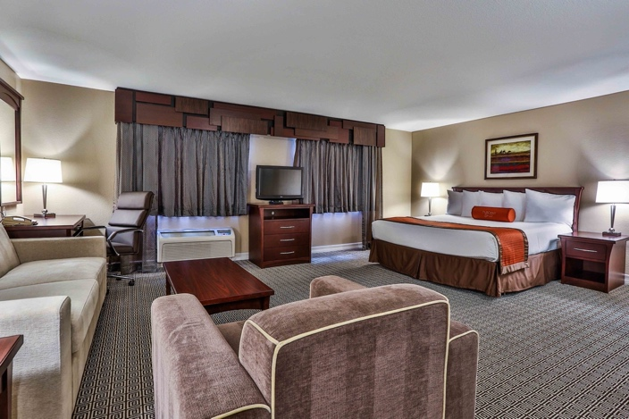
Tuscany Suites & Conference Center

Event Location
All events including tutorials, technical sessions, and exhibits, will occur on the hotel property. All events, including the opening ceremony and reception, will be clearly marked with signs. The Tuscany Suites is located at 255 East Flamingo Rd., Las Vegas, NV 89169.
Tel. 702-893-8933 / 1-877-887-2261

Hotel Reservations
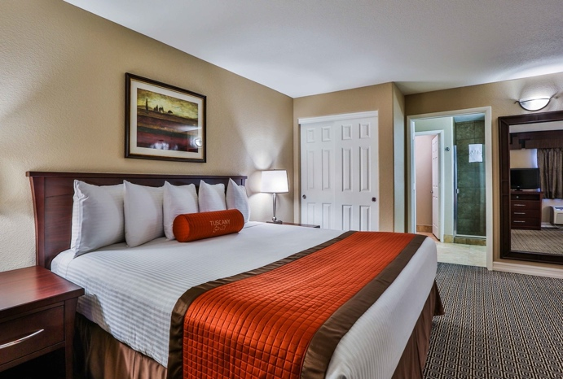
ITEA is pleased to offer a special below government per diem rate of $79 per night per night for Sunday – Thursday, and $149 per night for Friday and Saturday. Please specify that you will be attending the ITEA workshop when booking your reservation.

Room Block Cut-Off: April 13, 2022

Reservations via Web: Tuscany Reservation Link

Cancellations: The hotel requires a 72-hour cancellation
notice prior to the reservation date. Late cancellations will
result in the first night’s stay being billed to your credit
card.

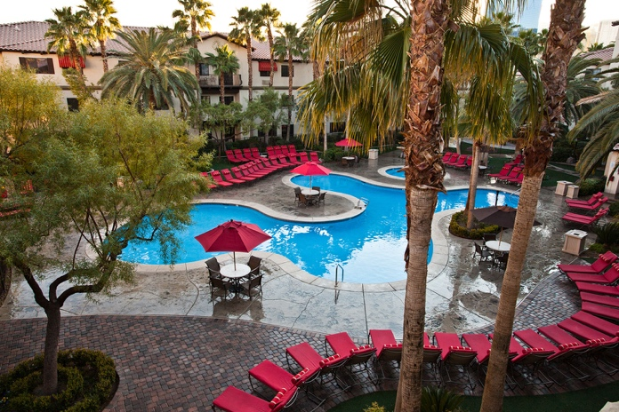
Check-In/Check-Out: Check-In time is 3:00pm and Check-out time is 11:00am.

Internet: Free WiFi throughout the hotel (includes conference space and sleeping rooms).

Parking: Free

Extras: Waived Resort Fee

Registration Information

Registration includes two lunches, breaks, & Networking Reception.

**One-year ITEA membership (if paying non-member fee).

NOTE: Pre-Workshop Tutorials require a separate fee from the Workshop.

Early Registration prior to April 15
$645 - Regular Registration**
$495 - ITEA Member / Government Employee / Active Duty Military
Regular Registration April 16-30
$745 - Regular Registration**
$595 - ITEA Member / Government Employee / Active Duty Military
Late Registration after April 30
$845 - Regular Registration**
$695 - ITEA Member / Government Employee / Active Duty Military
Early T&E Career Professional (less than 5 years of T&E experience) VERIFICATION REQUIRED – Includes two Lunches, breaks, and the Networking Reception, and a one-year ITEA membership for Non-ITEA Members.
$ 95 – Early registration prior to April 15th
$195 ($120 ITEA Member) – Registration April 16th -30th
$295 ($220 ITEA Member) – Late Registration after April 30th
Download verification form here
Pre-Workshop Tutorials (requires a separate fee from the Workshop)
Single Tutorial - $205, Two Tutorials - $385 (use discount code "Tutorial-Multi" at check out)

Special Registrations
- $150 - Plenary Speaker, Panel Chair, Session Chair, Tutorial Secondary Instructor
- $395 - Panelist, Technical Session Presenter (Includes membership)
- $150 - EXHIBIT HALL ONLY (Includes meals and Networking Reception/No access to Plenary or technical sessions)
- $50 - FULL-TIME STUDENT (ID Required)
- $400 One day only

SUBSTITUTION AND CANCELLATION POLICY: Substitutions are permitted. Refunds are not available within ten (10) days prior to the start of the event. Requests for cancellation submitted between ten (10) to 45 days prior to start date of the event will be subject to a $250 cancellation fee. Requests for cancellation greater than 45 days prior to the start date of the event will be subject to a $100 cancellation fee.

