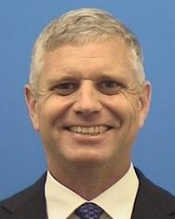
Hans Miller, Col USAF (ret), is a principal test and evaluation subject matter expert and project leader at the MITRE Corporation. He has over 28 years of experience in combat operations, experimental flight test, international partnering, command and control, policy, and strategic planning of defense weapon systems. Prior to his position at MITRE, Mr. Miller was the Division Chief of Policy, Programs and Resources at the USAF Headquarters for Test and Evaluation. Mr. Miller was the Commander of the 96th (now 406th) Test Group at Holloman AFB and the Commander of the Global Power Bomber Combined Test Force at Edwards AFB supporting B-1, B-2 and B-52 testing. Mr. Miller has experience working with international partners through a NATO assignment and as the program manager of the DoD Foreign Comparative Test Program. He has served as an operational and experimental flight test pilot in the B-1B and as an F-16 chase pilot. He flew combat missions in the B-1B in Operation Allied Force and Operation Enduring Freedom. Mr. Miller graduated from the United States Air Force Academy with a B.S. in Aeronautical Engineering and a Masters of Aeronautics and Astronautics from Stanford University. He is a graduate of the USAF Air War College, USAF Test Pilot School and USAF Weapons School.

