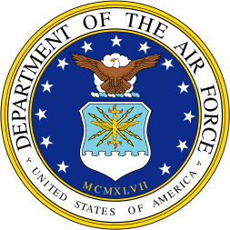  BIOGRAPHY |  | 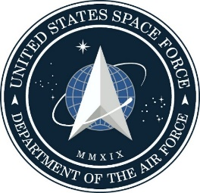

UNITED STATES SPACE FORCE
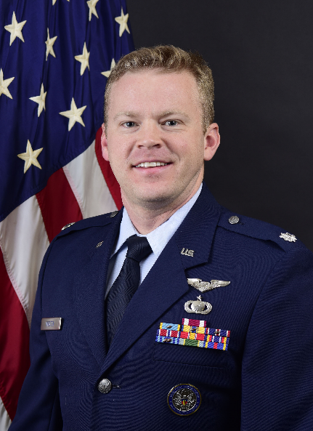
LIEUTENANT COLONEL MATTHEW C. WROTEN

Lt Col Matthew C. Wroten serves as the Deputy Director of USSF Test and Evaluation, Peterson Space Force Base, Colorado. In support of the director, he is responsible for organizing, training, and equipping test resources for USSF's $16B enterprise. He is a lead advisor on test and range issues, and directs strategy enabling validation of enterprise space capabilities. Additionally, he sets USSF test and evaluation policy, and provides service-wide oversight for developmental test, operational test, and weapon system and evaluation programs.

Prior to this assignment, Lt Col Wroten served as the Commander of the 846th Test Squadron, the "Holloman High Speed Test Track," Holloman Air Force Base, NM.
Lt Col Wroten was commissioned through the US Air Force Academy in 2003. His career has spanned several Test and Evaluation programs, including service as a Scientific Analyst, Flight Test Engineer, Test Conductor, and Test Director on A-10, C-5, T-38, F-16, KC-135, and F-35 test programs. In Academia, Lt Col Wroten served as an Assistant Professor of Probability and Statistics at the U.S. Air Force Academy. He currently holds a Level 3 certification in Test and Evaluation.

EDUCATION
2003 Bachelor of Science, Operations Research and Mathematical Sciences, U.S. Air Force Academy, Colorado
2005 Master of Science, Operations Research, Massachusetts Institute of Technology, Cambridge, Massachusetts
2008 U.S. Air Force Test Pilot School, Edwards AFB, California
2011 Squadron Officer School, Maxwell AFB, Alabama
2016 Air Command and Staff College, Maxwell AFB, Alabama
2017 Joint Professional Military Education Phase II, Joint Forces Staff College, Norfolk, Virginia

ASSIGNMENTS
1. May 2003 – Jun 2005, Student, Massachusetts Institute of Technology, Cambridge, Massachusetts
2. Jun 2005 – Dec 2007, Aircraft Test Analyst, HQ AFOTEC, Kirtland AFB, New Mexico
3. Dec 2007 – Dec 2008, Student, U.S. Air Force Test Pilot School, Edwards AFB, Calif.
4. Dec 2008 – Jul 2010, Assistant Flight Commander & Flight Test Engineer, 445 FLTS, Edwards AFB, Calif.
5. Jul 2010 – May 2012, Flight Commander & Flight Test Engineer, 461 FLTS, Edwards AFB, Calif.
6. May 2012 – Jul 2015, Assistant Professor of Mathematics and Executive Officer to the Dean of the Faculty, U.S. Air Force Academy, Colorado
7. Jul 2015 - Jun 2016, Student, Air Command and Staff College, Maxwell AFB, Alabama
8. Jun 2016 – Jun 2018, Deputy Mission Commander and Certification Director, Open Skies Division, Defense Threat Reduction Agency, Ft Belvoir, Virginia
9. Jun 2018 – Jun 2020, Commander, 846th Test Squadron, Holloman AFB, New Mexico
10. Jun 2020 – Present, Deputy Director, USSF Test and Evaluation, Peterson SFB, Colorado

MAJOR AWARDS AND DECORATIONS
Defense Meritorious Service Medal
Meritorious Service Medal with one oak leaf cluster
Aerial Achievement Medal with two oak leaf clusters
Air Force Commendation Medal with one oak leaf cluster

EFFECTIVE DATES OF PROMOTION
Second Lieutenant May 28, 2005
First Lieutenant May 28, 2007
Captain May 28, 2009
Major May 1, 2013
Lieutenant Colonel February 1, 2018

